Design Principles - Inversion of Control (IoC)
# Source: AI Source: Provided by: [Data Path: Persons Table -> ID Column: 1, Name_En Column: Motasem Essam] -> From: [Chatgpt (GPT‑5 Mini)] on [1/23/2026]
Inversion of Control (IoC) is the principle where high-level modules delegate the flow of control to lower-level modules or frameworks, rather than controlling everything themselves.
👉 Think of it like hiring a team of specialists — you define the goals, and they handle the details.

🔑 Key Points
# Source: AI Source: Provided by: [Data Path: Persons Table -> ID Column: 1, Name_En Column: Motasem Essam] -> From: [Chatgpt (GPT‑5 Mini)] on [1/23/2026]
• High-level components don’t instantiate or manage low-level modules directly
• Control flow is inverted: lower-level components are “called” when needed
• Supports decoupling, modularity, and testability
• Commonly implemented via Dependency Injection, Events, or Callbacks

❌ Bad Example
# Source: AI Source: Provided by: [Data Path: Persons Table -> ID Column: 1, Name_En Column: Motasem Essam] -> From: [Chatgpt (GPT‑5 Mini)] on [1/23/2026]
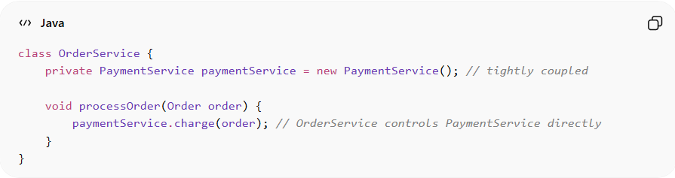
class OrderService {
private PaymentService paymentService = new PaymentService(); // tightly coupled

void processOrder(Order order) {
paymentService.charge(order); // OrderService controls PaymentService directly
}
}
Problems:
• OrderService controls the creation and usage of PaymentService
• Tightly coupled → hard to test or replace PaymentService
• Violates the IoC principle
• Hard to extend for different payment methods

✅ Good Example
# Source: AI Source: Provided by: [Data Path: Persons Table -> ID Column: 1, Name_En Column: Motasem Essam] -> From: [Chatgpt (GPT‑5 Mini)] on [1/23/2026]
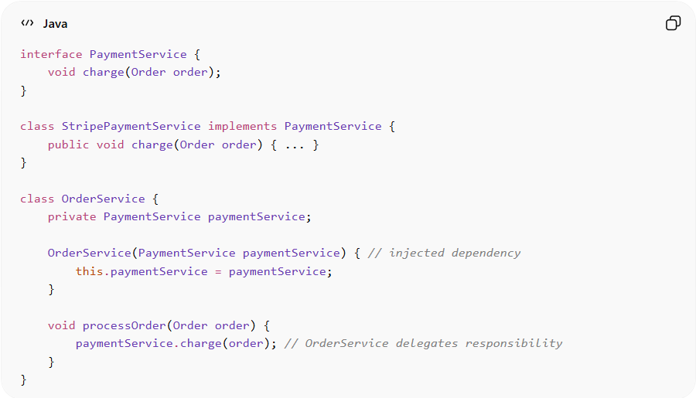
interface PaymentService {
void charge(Order order);
}

class StripePaymentService implements PaymentService {
public void charge(Order order) { ... }
}

class OrderService {
private PaymentService paymentService;

OrderService(PaymentService paymentService) { // injected dependency
this.paymentService = paymentService;
}

void processOrder(Order order) {
paymentService.charge(order); // OrderService delegates responsibility
}
}
Benefits:
• High-level module no longer controls low-level dependencies
• Easier to swap, test, or extend PaymentService
• Supports flexible, modular, and maintainable architecture
• Works naturally with frameworks and Dependency Injection

⚡ When to Apply
# Source: AI Source: Provided by: [Data Path: Persons Table -> ID Column: 1, Name_En Column: Motasem Essam] -> From: [Chatgpt (GPT‑5 Mini)] on [1/23/2026]
• In enterprise applications with multiple modules
• When building testable, flexible, and loosely coupled systems
• Works best with Dependency Injection frameworks (Spring, Guice, etc.)
• Combine with Hollywood Principle and SOLID principles for clean architecture

